Data Import Instructions: Step 1: DDL

SHOW DATABASES;

DROP DATABASE music_app;

CREATE DATABASE music_app;

USE music_app;

CREATE TABLE Artists (

id varchar(50),

name varchar(255),

genres text,

artist_popularity int,

followers int,

PRIMARY KEY (id)

);

CREATE TABLE Albums (

id varchar(50),

name varchar(255),

images text,

external_urls varchar(100),

album_type varchar(20),

total_tracks int,

artist_id varchar(50) NOT NULL,

PRIMARY KEY (id),

FOREIGN KEY (artist_id) REFERENCES Artists (id) );

CREATE TABLE Tracks (

id varchar(50),

name text,

preview_url varchar(120),

country varchar(10),

duration_ms int,

popularity int,

playlist varchar(100),

disc_number int,

track_number int,

on_key int,

time_signature int,

mode int,

acousticness float,

danceability float,

energy float,

instrumentalness float,

liveness float,

loudness float,

speechiness float,

tempo float,

valence float,

album_id varchar(50) NOT NULL,

PRIMARY KEY (id),

FOREIGN KEY (album_id) REFERENCES Albums (id)

);

Step 2: DataGrip Import Wizard

1. right click on table name 🡪 Import Data from File…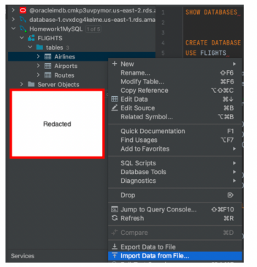

2. All 3 tables have the same specification below.

Make sure both “Quotation:” sections have only “ “ **Escape: duplicate**.